**Lesson 04 Demo 01**

**React with Redux to access Global variable**

**Objective:** To demonstrate the react with redux we can access redux global variable in all components.

**Tools required:** Node JS and React JS

**Prerequisites:** HTML, CSS, JavaScript ES5/ES6, Basic React Concept

**Note** : All react js project already created with version 18.x with Sample App.js file

**Steps to be followed:**

1. Set up for react js project
2. Create reducer, store and configuration for store in index.js function.
3. Create user defined component and with help of useSelector access store variable in each component ig global variable.
4. In App.js file import all user defined component and test the application.

**Step 1: Set up for react js project**

1. Open a terminal window inside a React JS pre-created project ie **react-redux-gs-variable**

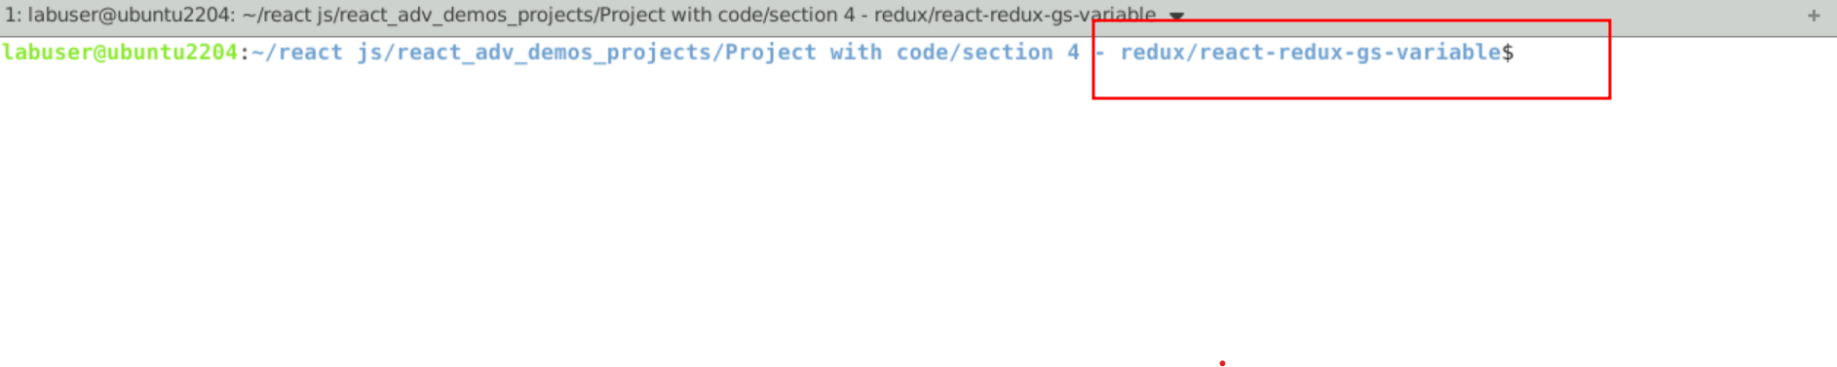

1. Now you need to run the command as **npm install.** This command helps us to installed all required dependencies mention in package.json file in local machine in the form of node_module folder.

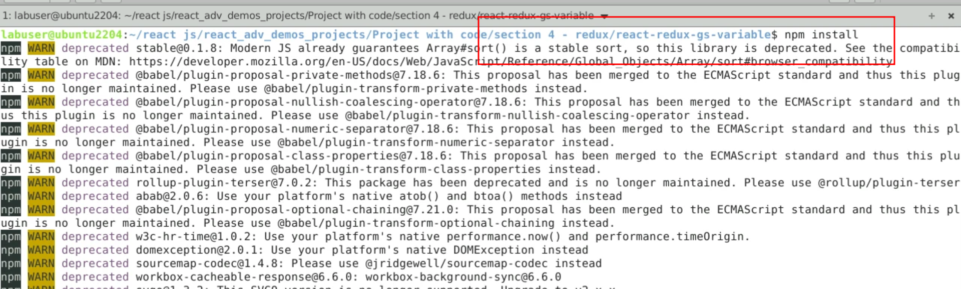

1. Now open **react-redux-gs-variable** folder in VS Code Editor

Note: short cut to open write **code .**

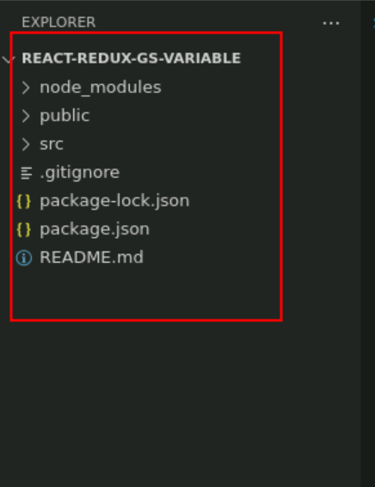

1.4 now open package.json file and view external dependencies.

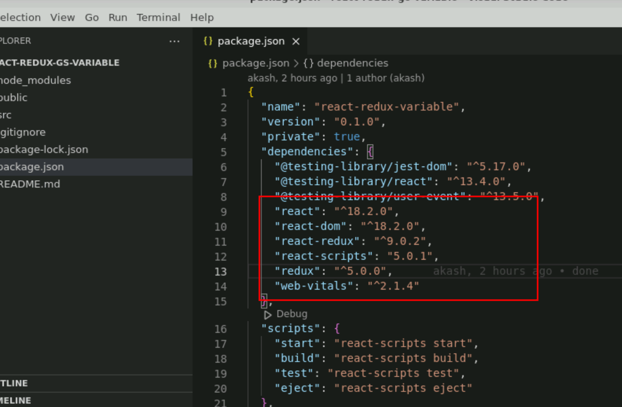

**Step 2:** Create reducer, store and configuration for store in index.js file

2.1 create reducer.js file. Which contains normal JavaScript function which takes two parameter ie state and action. Base upon action it will do some operation on state variable. And these variable as consider as global variable if we configure with store.

const initialState = {

name :"Admin",

customer:{cid:1,name:"Raj",age:21}

}

// Reducer

const reducer = (state = initialState, action) => {

// as of now no action.

return state;

};

export default reducer;

**2.2** We need to create react store with help of redux library. These store connect with reducer to make state variable as global variable.

Store.js

// Store

import { legacy_createStore as createStore} from 'redux'

import reducer from './reducer';

export const store = createStore(reducer);

**2.3 Now we need to configure store the index.js file. Inside this file we need to take the help of Provider part of react-redux and connect to store. Provider must be apply for whole application so wrap for App root components.**

import React from 'react';

import ReactDOM from 'react-dom/client';

import './index.css';

import App from './App';

import reportWebVitals from './reportWebVitals';

**import {store} from './store';**

**import { Provider } from 'react-redux';**

const root = ReactDOM.createRoot(document.getElementById('root'));

root.render(

<React.StrictMode>

**<Provider store={store}>**

<App />

**</Provider>**

</React.StrictMode>

);

// If you want to start measuring performance in your app, pass a function

// to log results (for example: reportWebVitals(console.log))

// or send to an analytics endpoint. Learn more: https://bit.ly/CRA-vitals

reportWebVitals();

**Step 3 :** Create user defined component and with help of useSelector access store variable in each component ig global variable.

3.1 create FirstComponent.js file. Here creates state variable as well as access react global variable with help of useSelector hook.

import { useState } from "react";

import { useSelector } from "react-redux";

function FirstComponent() {

let [name,setState]=useState("John");

let globalName = useSelector(gs=>gs.name)

return(

<div>

<h3>First Component</h3>

<p>State variable value is {name}</p>

<p>Global varilabe value is {globalName}</p>

</div>

)

}

export default FirstComponent;

3.2 create SecondComponent.js file. Here creates state variable as well as access react global variable with help of useSelector hook.

import { useState } from "react";

import { useSelector } from "react-redux";

function SeconComponent() {

let [name,setState]=useState("Steven");

let globalName = useSelector(gs=>gs.name)

return(

<div>

<h3>Second Component</h3>

<p>State variable value is {name}</p>

<p>Global varilabe value is {globalName}</p>

</div>

)

}

export default SeconComponent;

**3.3** Create Customer component.Here you can access global state complex object in customer components.

import { useState } from "react";

import { useSelector } from "react-redux";

function Customer() {

let customer = useSelector(gs=>gs.customer)

return(

<div>

<h3>Customer Information</h3>

<p>Customer Id {customer.cid} Name is {customer.name} Age is {customer.age}</p>

</div>

)

}

export default Customer;

**Step 4.** In App.js file import all user defined component and test the application.

**4.1** In App.js file import FirstCompoennt, SecondCompoent and CustomerCompoennt to test the application.

import logo from './logo.svg';

import './App.css';

import FirstComponent from './FirstComponent';

import SeconComponent from './SecondComponent';

import Customer from './Customer';

function App() {

return (

<div className="App">

<h3>Main Component</h3>

<hr/>

<FirstComponent></FirstComponent>

<hr/>

<SeconComponent></SeconComponent>

<hr/>

<Customer></Customer>

</div>

);

}

export default App;

**4.2 Now we run the application using npm start**

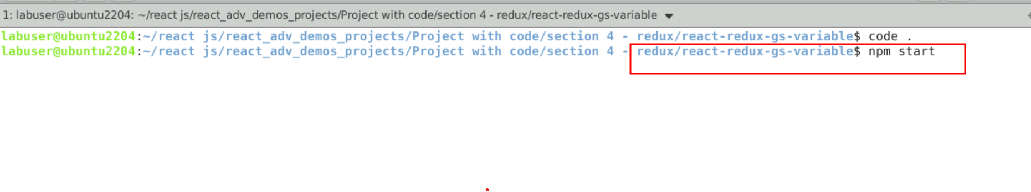

**4.3** Now you can view the output on browser. Here admin name as well as customer details are global variable we can access in each component.

